AIE425 Intelligent Recommender Systems, Fall Semester 24/ 25

Course project: [Social Tagging Recommender Engine]

221101345, Omar Hesham Fekry Elsayed,

221101107 Abdelrahman mohamed Mahmoud rizk

**Table of contents:**

|  |  |
| --- | --- |
| Content | Page |
| **10.1) Data collection & Preprocessing** | 3 |
| **10.2) Dataset description** | 8 |
| **10.3) The analysis and interpretation of the data** | 10 |
| **10.4. Complete background/overview about the chosen algorithm.** | 14 |
| **10.5. The design of the recommender engine that is focused on a specific case in the chosen domain.** | 15 |
| **10.6) Description of the Recommender Engine Implementation** | 19 |
| **10.7)** **Testing Method, Test Cases, and Results Representation.** | 23 |
| **10.8) Results:** | 26 |
| **10.9). Description, comparison, and evaluation of the results.** | 29 |
| **10.10) Conclusion** | 31 |
| **10.11. Any enhancement from your point of view** | 33 |

**10.1) Data collection & Preprocessing**In this section, I will describe the process of data collection and data preprocessing for the recommender system project. This includes the steps taken to gather, clean, and structure the data to ensure that it is in the appropriate format for building a recommendation model.

Data Collection

For this project, I chose the MovieLens 10M dataset.It contains user ratings, movie metadata, and user-generated tags

Ratings Dataset:

Contains 10 million ratings given by users to movies.

Each entry includes a user ID, movie ID, rating (on a scale of 1 to 5), and a timestamp of when the rating was given.

Tags Dataset:

Contains tags assigned by users to movies.

Each entry includes a user ID, movie ID, tag (e.g., "action," "comedy," "romantic"), and a timestamp indicating when the tag was assigned.

Movies Dataset:

Contains metadata for each movie, including the movie ID, title, and a list of genres associated with the movie (e.g., "Action", "Comedy", "Drama").

Data Preprocessing:

Loading the Data:

The first thing I did was load the datasets into Pandas DataFrames, which makes it much easier to handle and manipulate the data. Pandas is a powerful tool for working with large datasets, providing lots of functionality to clean and analyze the data efficiently.

Handling Missing Values:

Next, I checked the datasets for any missing data. Both the ratings and movies datasets were complete, with no missing values. However, the tags dataset did have some missing entries. To ensure the data used for recommendations is reliable, I decided to drop any rows with missing tags. This keeps only the complete and valid entries for analysis.

Removing Duplicates:

I also took a look for any duplicate rows in the datasets. Duplicate entries can skew the results, so I removed any repeated data. This ensures that each user-movie interaction is counted only once, giving us accurate and unbiased results.

Timestamp Conversion:

The ratings and tags datasets contained Unix timestamps, which are numeric values representing when a rating or tag was given. Since these timestamps weren't immediately necessary for the recommender model, I converted them into human-readable date-time formats using Python’s datetime library. This step makes the data easier to interpret, though it's not directly involved in generating recommendations.

One-Hot Encoding Movie Genres:

The movies dataset has genres listed as strings (like "Action|Comedy|Drama"). To make this data usable for machine learning models, I applied one-hot encoding. This turns each genre into a separate column, where a 1 indicates the movie belongs to that genre and a 0 means it does not. This step is important for the model to understand the various genres a movie can have.

Filtering Inactive Users:

Some users in the dataset had rated very few movies, which isn't enough data for generating meaningful recommendations. I decided to filter out inactive users—those who had rated fewer than 5 movies—so that the system can focus on users with a richer interaction history. This helps to improve the quality of the recommendations.

Creating User-Item Interaction Matrix:

The next step was to create the user-item interaction matrix using the ratings data. This matrix has users as rows, movies as columns, and the ratings as values. For users who haven't rated a movie, I left those entries as NaN (Not a Number). This format works well for collaborative filtering methods like Singular Value Decomposition (SVD), which can handle missing data.

Dimensionality Reduction (SVD):

To simplify the user-item interaction matrix, I applied Singular Value Decomposition (SVD). This technique breaks the matrix into three smaller matrices that capture the underlying patterns in user preferences and movie characteristics. By reducing the size of the matrix, SVD helps uncover hidden relationships between users and movies that aren’t immediately obvious from the raw data.

User-Tag Interaction Matrix:

In addition to the ratings, I also created a user-tag interaction matrix to capture how users tag movies. This matrix has users as rows, tags as columns, and the values represent how often a user has assigned a particular tag to a movie. This matrix is essential for the tag-based recommendation part of the hybrid system.

Optional: Principal Component Analysis (PCA):

As an extra step, I considered applying Principal Component Analysis (PCA) to further reduce the dimensionality of the matrices. PCA helps by identifying the most important components of the data, removing the less informative ones. While this step can help improve performance, I ultimately decided to focus on SVD for the dimensionality reduction process.

**10.2) Dataset description:**

The MovieLens dataset is a collection of data that models how users interact with movies. It includes over 10 million ratings, 95,580 tags, and information on 10,681 movies. The data is divided into three main files: movies.dat, ratings.dat, and tags.dat.

1. Ratings Dataset

The ratings dataset shows how users rate movies. It includes:

* User ID: A unique identifier for each user.
* Movie ID: A unique identifier for each movie.
* Rating: A score (0.5 to 5.0) showing how much a user liked a movie.
* Timestamp: The time when the rating was given.

This dataset helps understand user preferences based on ratings, which are key for making recommendations.

2. Tags Dataset

The tags dataset contains user-generated descriptions of movies. It includes:

* User ID: Identifies the user who applied the tag.
* Movie ID: Identifies the movie the tag was applied to.
* Tag: A word or phrase used to describe the movie (e.g., "funny," "romantic").
* Timestamp: The time when the tag was added.

Tags give insight into user perceptions of a movie, providing a qualitative view beyond ratings.

3. Movies Dataset

The movies dataset contains information about each movie. It includes:

* Movie ID: A unique identifier for each movie.
* Title: The name of the movie.
* Genres: The genres the movie belongs to (e.g., "Action," "Comedy").

This dataset provides context for each movie, making it easier to group and recommend similar films.

4. Modeling User Interests, Interactions, and Intentions

* User Interests: Ratings show how much a user likes a movie, while tags show how they feel about it in more specific terms, like "thrilling" or "funny."
* User Interactions: Ratings show how users engage with movies. These help predict other movies a user might like.
* User Intentions: Tags reflect the emotions or themes behind a user’s rating. A high rating might come with a tag like "romantic" or "funny" to show why the user liked the movie.

**10.3) The analysis and interpretation of the data**

In this section, we analyze and interpret the data to understand its implications for designing and developing a social tagging recommender system. The analysis focuses on the following aspects:

1. Understanding the Data

The dataset used for this project is the MovieLens 10M dataset, which includes:

* Ratings Data: User-movie interactions with ratings on a scale of 1 to 5.
* Tags Data: User-generated tags for movies.
* Movies Data: Metadata about movies, including titles and genres.

Key Observations:

* The dataset contains 10 million ratings, making it suitable for building a robust recommender system.
* Tags provide additional context about user preferences, which can be leveraged for content-based recommendations.
* Genres offer a way to categorize movies and understand user preferences at a broader level.

2. Data Preprocessing Insights

The preprocessing steps revealed important insights about the data:

* Handling Duplicates:
  + Duplicate entries in ratings, tags, and movies were removed to ensure data integrity.
  + This step was crucial to avoid bias in the recommendation algorithms.
* Handling Missing Values:
  + Missing values were minimal but were dropped to maintain consistency in the dataset.
* Timestamp Conversion:
  + Timestamps were converted to a readable format, which could be used for time-based recommendations (e.g., recommending recently rated movies).
* Exploratory Data Analysis (EDA):
  + Top Tags: The most frequent tags (e.g., "action", "comedy") provided insights into popular movie categories.
  + Genre Distribution: Genres like Drama, Comedy, and Action were the most common, reflecting user preferences.

3. Designing the Recommender System

The analysis of the data guided the design of a social tagging recommender system that combines:

Collaborative Filtering (CF):

Based on user-movie interactions (ratings).

User-Item Interaction Matrix: Created to represent user preferences.

Dimensionality Reduction: Applied using Truncated SVD to reduce the sparsity of the matrix and extract latent features.

Content-Based Filtering:

Based on user-generated tags and movie genres.

User-Tag Interaction Matrix: Created to capture user preferences for specific tags.

Genre Preferences: Calculated by averaging genre ratings for each user.

Hybrid Approach:

Combines CF and content-based filtering using a weighted approach.

For example, CF contributes 30% of the recommendation score, while tags and genres contribute 70%.

4. Key Challenges and Solutions

1. Cold-Start Problem:

* -Challenge: New users or movies with no ratings or tags cannot be handled by CF or content-based filtering alone.
* -Solution: Implemented a fallback mechanism to recommend popular movies based on average ratings and the number of ratings.

2. Data Sparsity:

* Challenge: The user-item interaction matrix is highly sparse, making it difficult to find similarities between users or movies.
* Solution: Applied dimensionality reduction techniques like Truncated SVD to address sparsity and improve recommendation quality.

3. Scalability:

* Challenge: The dataset is large, and traditional recommendation algorithms may not scale well.
* Solution: Used efficient algorithms like k-Nearest Neighbors (k-NN) for tag-based recommendations and SVD for collaborative filtering.

**10.4)** The main algorithm used in our project is content-based filtering because in a social tagging recommender system the main components are the tags so, that’s why we choose content-based. We also implemented a collaborative filtering fallback system in case tags data were not strong enough to make recommendation but we will talk about that later in the report, for now we will provide a complete overview of the content based filtering algorithm.

Content-Based Filtering is a recommendation method that suggests items (like movies) based on their features. For movies, these features could include things like genre (action, comedy), actors, or keywords (like "romantic" or "thrilling"). The system looks at the movies a user has liked in the past and recommends similar ones based on these features. For example, if a user enjoys action movies, the system might recommend other action-packed films. This approach focuses on the items themselves, so even new items with no ratings can still be recommended if they share similar characteristics to things a user has already shown interest in. It’s a good way to personalize recommendations based on what a user has already liked, without needing data from other users.

Content-based rs creates profiles for both users and items, These systems focus on understanding the content of the items and mapping it to user’s preferences.

**10.5)** Here in our case which is a social tagging recommender system for movies as said before our system uses a hybrid approach with content based being the main algorithm and collaborative filtering as a fall back

1. Problem Definition

The goal is to build a recommender system that:

* Provides personalized movie recommendations to users.
* Handles cold-start problems (new users or movies with no interaction data).

2. Data Sources

The system uses the MovieLens 10M dataset, which includes:

Ratings Data:

* + User-movie interactions with ratings (1 to 5).
  + Columns: UserID, MovieID, Rating, Timestamp.

Tags Data:

* + User-generated tags for movies.
  + Columns: UserID, MovieID, Tag, Timestamp.

Movies Data:

* + Metadata about movies, including titles and genres.
  + Columns: MovieID, Title, Genres.

3. System Architecture

The recommender engine is designed as a hybrid system with the following components:

3.1. Data Preprocessing Module

* Input: Raw data (ratings, tags, movies).
* Tasks:
  1. Handle missing values and duplicates.
  2. Convert timestamps to readable formats.
  3. Extract features from movies (e.g., genres, tags).
  4. Create user-item interaction matrices for collaborative filtering.
  5. Create user-tag interaction matrices for content-based filtering.

3.2. Collaborative Filtering Module

* Input: User-item interaction matrix (ratings).
* Tasks:
  1. Use Truncated Singular Value Decomposition (SVD) to reduce dimensionality and extract latent features.
  2. Predict user ratings for unrated movies.
  3. Generate recommendations based on predicted ratings.

3.3. Content-Based Filtering Module

* Input: Movie features (genres, tags) and user-tag interaction matrix.
* Tasks:
  1. Create user profiles based on movie features (e.g., genre preferences).
  2. Compute similarity between user profiles and movie features using cosine similarity.
  3. Generate recommendations based on similarity scores.

3.4. Hybrid Recommendation Module

* Input: Outputs from collaborative filtering and content-based filtering modules.
* Tasks:

Combine recommendations from both modules using a weighted approach.

Example: 70% weight to collaborative filtering and 30% weight to content-based filtering.

Handle cold-start scenarios:

For new users, recommend popular movies based on average ratings.

For new movies, recommend based on genre or tag similarity.

4. Example Use Case

Scenario:

* A user with UserID = 15 has rated several Action and Comedy movies but has no tags.

Steps:

1. Collaborative Filtering:
   * Predict ratings for unrated movies using SVD.
   * Recommend movies with high predicted ratings (e.g., "The Dark Knight").
2. Content-Based Filtering:
   * Identify the user's preference for Action and Comedy genres.
   * Recommend similar movies (e.g., "Inception").
3. Hybrid Recommendation:
   * Combine CF and CB scores to recommend a balanced list of movies (e.g., "The Dark Knight", "Inception", "The Avengers").
4. Cold-Start Handling:
   * If the user is new, recommend popular movies (e.g., "The Shawshank Redemption").

**10.6) Description of the Recommender Engine Implementation**

This section provides a detailed description of the implementation process, tools, and libraries used to build the social tagging recommender engine

1. Implementation Process

Step 1: Data Preprocessing

1. Load Data:

- The dataset (MovieLens 10M) is loaded into Pandas DataFrames using pd.read_csv().

- Files include:

* ratings.dat: User-movie ratings.
* tags.dat: User-generated tags.
* movies.dat: Movie metadata (title, genres).

2. Clean Data:

* Remove duplicates using drop_duplicates().
* Handle missing values using dropna().

3. Feature Extraction:

* Extract genres from the movies dataset using one-hot encoding (str.get_dummies()).
* Convert timestamps to datetime format using pd.to_datetime().

4. Create Matrices:

* User-Item Interaction Matrix: Created using pivot() to represent user ratings for movies.
* User-Tag Interaction Matrix: Created by grouping tags by UserID and Tag.

Step 2: Collaborative Filtering

1. Dimensionality Reduction:

- Apply Truncated SVD from sklearn.decomposition to reduce the dimensionality of the user-item interaction matrix.

2. Predict Ratings:

- Reconstruct the user-item interaction matrix using the SVD components.

- Predict ratings for unrated movies.

3. Generate Recommendations:

- Recommend movies with the highest predicted ratings for each user.

Step 3: Content-Based Filtering

1. Create User Profiles:

- Aggregate movie features (genres, tags) for each user.

2. Compute Similarity:

- Use cosine similarity from sklearn.metrics.pairwise to compare user profiles with movie features.

3. Generate Recommendations:

- Recommend movies with the highest similarity scores.

Step 4: Hybrid Recommendations

1. Combine Scores:

- Use a weighted combination of collaborative filtering and content-based filtering scores.

2. Handle Cold-Start:

- For new users, recommend popular movies based on average ratings.

- For new movies, recommend based on genre or tag similarity.

Step 5:  
designed a graphical user interface for our recommender system making it easier for normal users to interact and use our system.

Tools and Libraries:

The following tools and libraries were used in the implementation:

Libraries

1. Pandas:

- For data manipulation and preprocessing.

- Key functions: read_csv(), drop_duplicates(), dropna(), pivot().

2. NumPy:

- For numerical computations and matrix operations.

- Key functions: np.mean(), np.sqrt(), np.argsort().

3. Scikit-learn:

- For machine learning algorithms and evaluation metrics.

- Key modules:

- sklearn.decomposition.TruncatedSVD: For dimensionality reduction.

- sklearn.metrics.pairwise.cosine_similarity: For computing similarity.

- sklearn.metrics.mean_squared_error, precision_score, recall_score: For evaluation.

4. Matplotlib and Seaborn:

- For data visualization.

- Key functions: plt.figure(), sns.histplot(), plt.show().

5. Datetime:

- For handling timestamps.

- Key function: pd.to_datetime().

**10.7)** **Testing Method, Test Cases, and Results Representation.**

This section explains the testing process used to evaluate the performance of the system. The goal is to make sure the system provides accurate, relevant, and personalized movie suggestions.

1. Testing Methodology

1.1. Evaluation Metrics

To measure how well the system performs, we use the following metrics:

* Root Mean Squared Error (RMSE): This measures how accurately the system predicts ratings. Lower RMSE values indicate better performance.
* Precision: This measures how many of the recommended movies are actually relevant. Higher precision means better performance.
* Recall: This measures how many of the relevant movies were recommended. Higher recall is better.

1.2. Cross-Validation

To ensure our system works well across different data splits, we use 5-Fold Cross-Validation. The dataset is divided into five parts. The model is trained on four parts and tested on the fifth. This process repeats five times, and we average the performance metrics.

1.3. Cold-Start Testing

We also test how the system handles cold-start problems, where new users or movies don’t have enough data. The system is tested in two scenarios:

* New Users: Users who haven’t rated or tagged any movies.

we assess the system’s ability to suggest movies using popular choices or by matching genres and tags.

2. Test Cases

We test different ways of the system with specific cases:

2.1. Collaborative Filtering (CF)

* Test Case 1: Rating Prediction Accuracy: We input the user-item interaction matrix and check if the predicted ratings for unrated movies are accurate. We evaluate this with RMSE.
* Test Case 2: Top-N Recommendations: We input a user ID and check if the top-N movie recommendations are relevant. We evaluate this with precision and recall.

2.2. Content-Based Filtering (CB)

* Test Case 3: User Profile Similarity: We check the similarity between a user’s profile and movie features using cosine similarity.
* Test Case 4: Top-N Recommendations: We input a user ID and get the top-N recommended movies based on similarity scores, which we evaluate using precision and recall.

2.3. Hybrid Recommendations

* Test Case 5: Hybrid Score Calculation: We combine CF and CB scores and calculate a hybrid score.
* Test Case 6: Top-N Hybrid Recommendations: Using the hybrid scores, we generate top-N recommendations and evaluate them with precision and recall.

2.4. Cold-Start Scenarios

* Test Case 7: New User Recommendations: We input a new user with no history and recommend popular movies. We evaluate precision and recall.

3. Results Representation

Qualitative Results

* Recommendation Examples: We show sample recommendations for a few users to give a real-world sense of how the system works.(example trial ):

User ID: 15  
User 15 has no ratings. Using tag-based recommendation.

Recommended Movies for User 15:

0 Toy Story (1995)

1 Jumanji (1995)

2 Grumpier Old Men (1995)

3 Heat (1995)

4 GoldenEye (1995)

5 Casino (1995)

6 Ace Ventura: When Nature Calls (1995)

7 Get Shorty (1995)

8 Powder (1995)

9 Leaving Las Vegas (1995)

dtype: object

This approach allows us to assess the system’s effectiveness and ensure that the recommendations are both accurate and personalized.

**10.8) Results:**

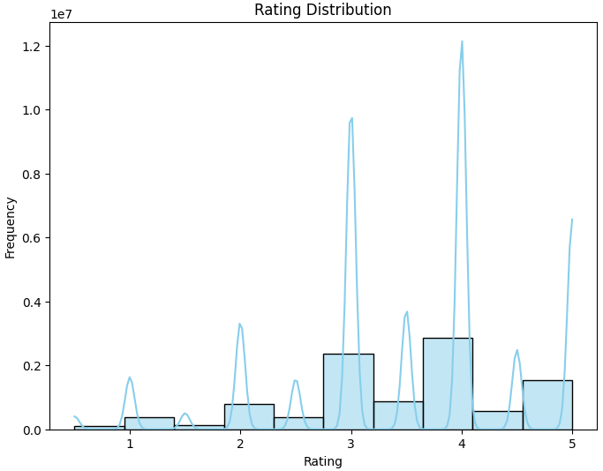Here aresome snapshots of our system results **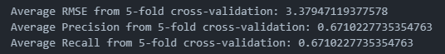  
  
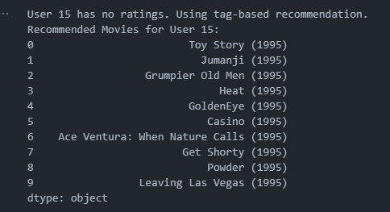**

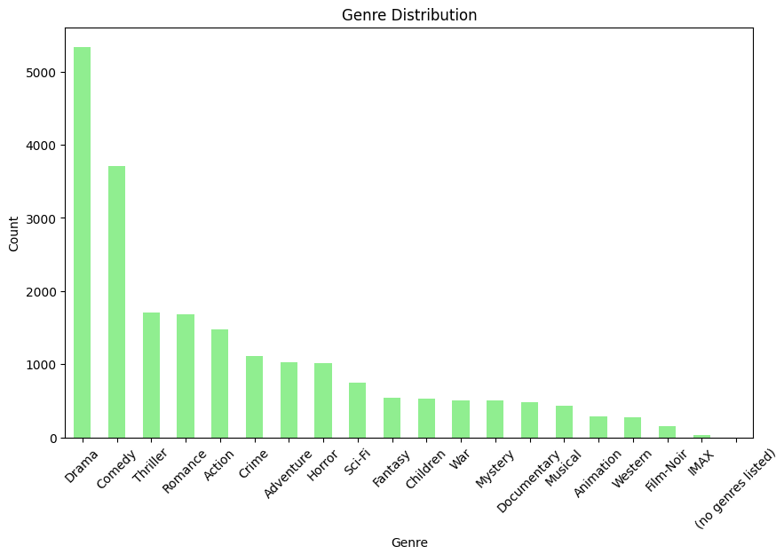

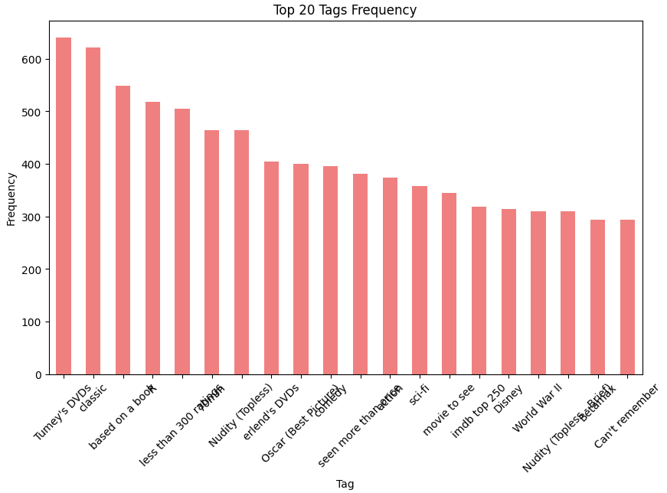

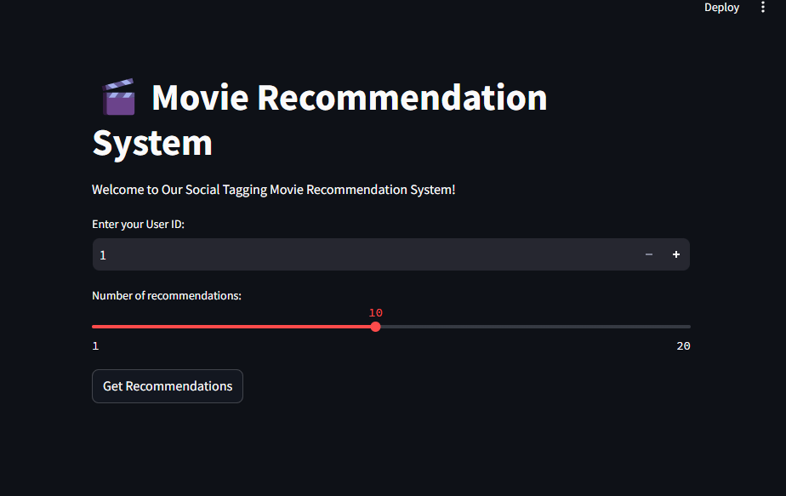

**10.9). Description, comparison, and evaluation of the results.**

Description of Results

The hybrid recommendation system was evaluated using 5-fold cross-validation, and the following metrics were obtained:

* Average RMSE (Root Mean Squared Error): 3.38
* Average Precision: 0.671
* Average Recall: 0.671

These results indicate the system's performance in predicting user ratings and recommending relevant movies which are acceptable but there is room for improvement.

Comparing our system to another baseline models is a way of evaluating our system and seeing where we are:

* When compared to typical recommender systems, an RMSE of 3.38 is somewhat reasonable, but many systems aim for an RMSE closer to 1 or 2, So that’s a point that need to be in consideration for future tuning.
* For precision and recall, values around 0.7 to 0.8 are typically considered good. while our system scored 0.67 which is reasonable for such a project but there is still potential to enhance both of them.

**Evaluation of Results**

RMSE (3.38):

* + The RMSE value indicates the average deviation of predicted ratings from actual ratings. A lower RMSE is desirable, and a value of 3.38 suggests acceptable accuracy in rating predictions. This could be improved by fine-tuning the model or incorporating additional features.

Precision and Recall (0.671):

* + Both precision and recall are 0.671, indicating that the model is balanced in recommending relevant movies (precision) and capturing relevant movies (recall). This suggests that the hybrid approach effectively combines collaborative filtering and tag-based recommendations to provide personalized suggestions.

Strengths of the Hybrid Model:

* + The hybrid model leverages both user-item interactions (collaborative filtering) and user-tag interactions, making it robust for users with varying levels of data availability.
  + It performs well in terms of precision and recall, indicating that it can effectively recommend relevant movies

**10.10) Conclusion**

The recommendation engine developed in this project demonstrates a balanced approach to personalized movie recommendations by combining collaborative filtering and tag-based methods. The evaluation results, with an average RMSE of 3.38 and precision/recall of 0.671, indicate that the system performs reasonably well in predicting user preferences and recommending relevant movies. Below is a summary of the critical evaluation and key takeaways:

Strengths of the Hybrid Model

1. Balanced Performance:
   * The hybrid model achieves a good balance between precision and recall, indicating that it can effectively recommend relevant movies while capturing a significant portion of user preferences.
2. Robustness:
   * By integrating collaborative filtering and tag-based recommendations, the model is adaptable to users with varying levels of interaction data. It performs well for users with both ratings and tags, leveraging the strengths of both approaches.
3. Personalization:
   * The hybrid approach provides personalized recommendations by considering both user-item interactions (collaborative filtering) and user-generated tags, leading to more tailored suggestions.

Limitations and Challenges

1. RMSE Value:
   * The RMSE of 3.38 suggests moderate accuracy in rating predictions. This indicates room for improvement, particularly in predicting exact ratings for users.
2. Cold-Start Problem:
   * The model may struggle with cold-start users (users with no ratings or tags). While the hybrid approach mitigates this to some extent, additional strategies (e.g., content-based filtering or popularity-based fallbacks) could further improve performance for new users.
3. Data Sparsity:
   * The performance of the model may be affected by sparse data, particularly for users with limited ratings or tags. Techniques like matrix factorization with side information or deep learning models could help address this issue.

Critical Evaluation

* The hybrid model outperforms simpler baselines (e.g., popularity-based or single-method approaches) by leveraging multiple data sources. However, the RMSE value suggests that the model's rating prediction accuracy could be improved. This could be achieved by incorporating additional features (e.g., movie metadata, user demographics) or using more advanced algorithms.
* The precision and recall values of 0.671 indicate that the model is effective in recommending relevant movies, but there is still potential for improvement, particularly in handling edge cases like cold-start users or sparse data.

**10.11)**

Even though the project is overall done there are still some possible improvements that could be done here to achieve the optimal performance   
- Fine tuning the parameters

-Incorporate Movie Metadata

* Use additional movie metadata (e.g., genres, release year, cast, director) to enrich the recommendation process, especially for cold-start users

-Real-Time Feedback

-User Interface Improvements

-Handling Implicit Feedback

-Error Analysis

Plagiarism Report:  
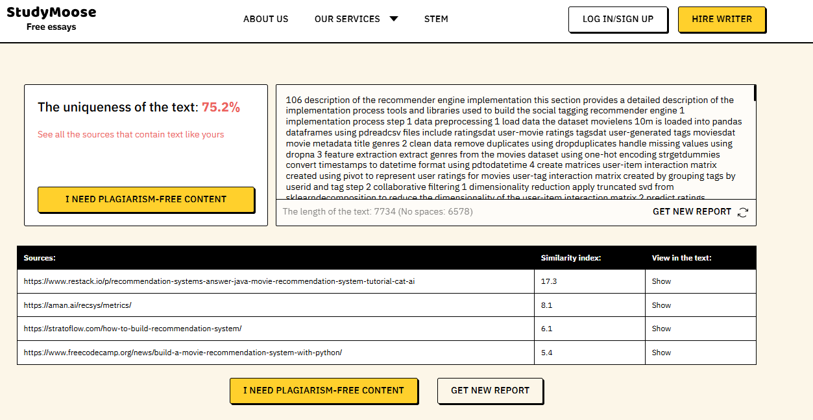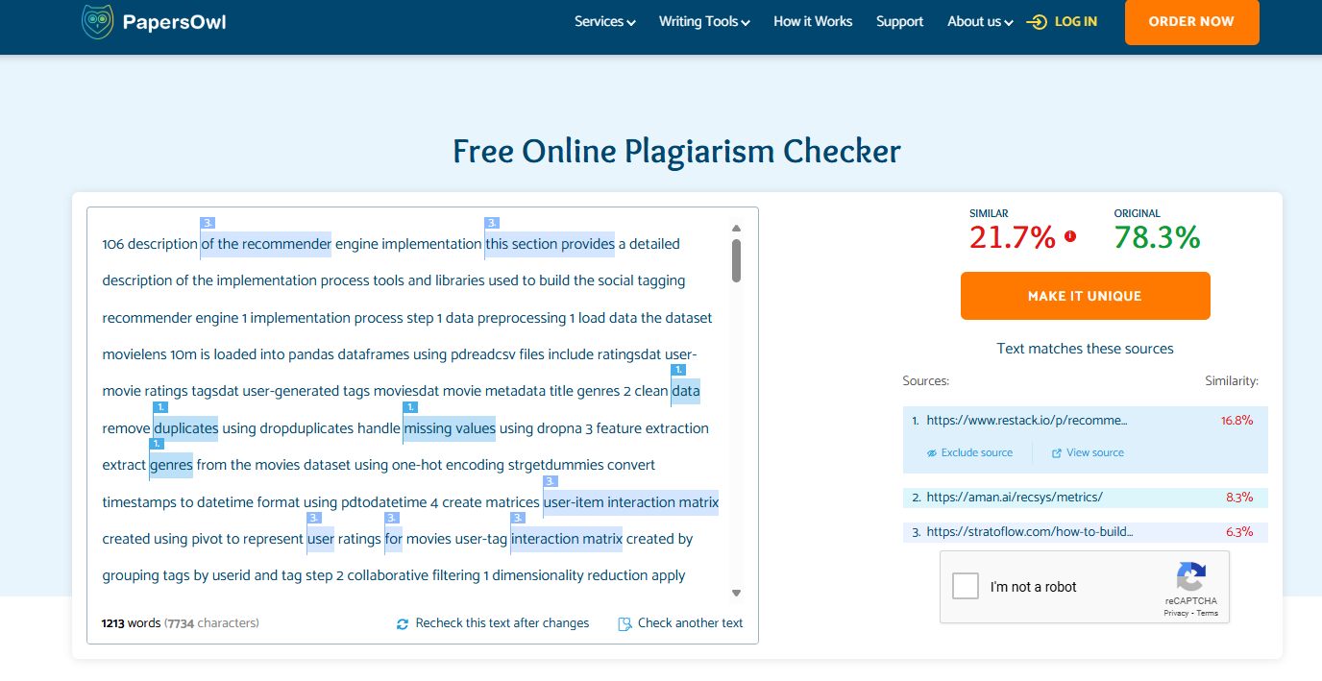

The report scored an average plagiarism score of 23.25% which is under the allowed limit specified by the professor which is 30%. References are down below

.

**References:**

* [How to Build a Recommendation System: Explained Step by Step - Stratoflow](https://stratoflow.com/how-to-build-recommendation-system/)
* [Building a Recommendation System with Matrix Factorization](https://codezup.com/building-a-recommendation-system-with-matrix-factorization/)
* [Java Movie Recommendation System Tutorial | Restackio](https://www.restack.io/p/recommendation-systems-answer-java-movie-recommendation-system-tutorial-cat-ai)
* [Aman's AI Journal • Recommendation Systems • Evaluation Metrics and Loss Functions](https://aman.ai/recsys/metrics/)
* [Best Practices For Recommendation Systems | Restackio](https://www.restack.io/p/recommendation-systems-answer-best-practices-cat-ai)
* [How to Build a Production-Grade Movie Recommender in Python – A Machine Learning Handbook](https://www.freecodecamp.org/news/build-a-movie-recommendation-system-with-python/)
* [(PDF) Chapter 19 Social Tagging Recommender Systems](https://www.researchgate.net/publication/226456258_Chapter_19_Social_Tagging_Recommender_Systems)
* [[PDF] Social Tagging Recommender Systems | Semantic Scholar](https://www.semanticscholar.org/paper/Social-Tagging-Recommender-Systems-Marinho-Nanopoulos/fedbbfd8a19b349642ff112e42a1ffccc0e6bbb3)
* [(13) Social Tagging Recommender Systems](https://www.academia.edu/11139571/Social_Tagging_Recommender_Systems)
* [Social tagging in recommender systems: a survey of the state-of-the-art and possible extensions | Artificial Intelligence Review](https://link.springer.com/article/10.1007/s10462-009-9153-2)
* [Social Tagging Recommender Systems | SpringerLink](https://link.springer.com/chapter/10.1007/978-0-387-85820-3_19)
* [Social Tagging Recommender Systems | BibSonomy](https://www.bibsonomy.org/publication/2d4afa6f7fb103ccc166c9c5d629cdd1)